Algorithms & Data Structures
Excercise-2

Code:

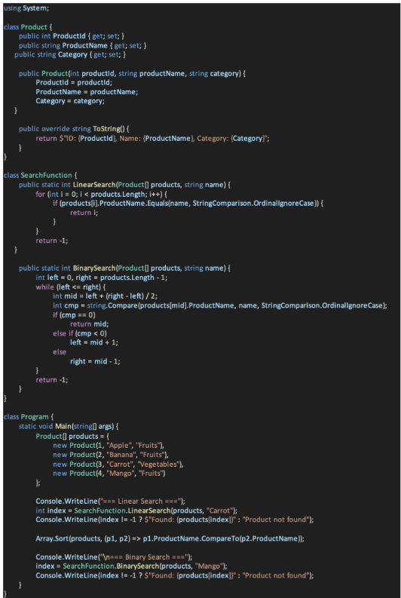

Output: 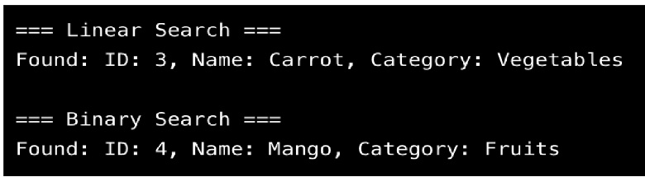

Analysis:

- Linear Search: O(n)
- Binary Search: O(log n) (on sorted data)
- Use Binary Search for performance-critical scenarios with sorted data.

